Instructions

Preamble
Welcome to this experiment. Thank you for coming. Please read carefully these instructions. They are to help you to understand what you will be asked to do. You are going to earn money for your participation in the experiment and you will be paid immediately after its completion.

The Experiment
You will be presented with a series of 100 problems, all of the same type. In each problem, there are a set of integer payoffs, about which you initially know nothing. During any problem, you might choose to incur some costs to get information about the payoffs. At the end of any problem you will get a particular one of these payoffs. We call your income for any problem this payoff minus any costs of information that you expended in that problem. Your payment for participating in this experiment will be determined by the average income from these problems, plus a £2.50 show-up fee.

At the beginning of each problem you will not be told anything about these payoffs other than they are between 1 and 100; the payoffs can be anywhere between and including 1 and 100. In fact, they will be randomly distributed between these bounds with what is known as an ambiguous distribution. As such a distribution is important to the experiment; we should describe it in more detail.

Ambiguous and uniform risky distributions
Examine Figures 1 and 2 at the end of these instructions. To produce each of these figures we replicated 49 times the drawing of 10,000 random numbers. For Figure 1 we generated them as uniformly distributed random numbers. You will see that the number of times that each number between 1 and 100 came up was roughly the same (around 100) on each replication; so one can conclude that the probability of any number coming up in the experiment is 1 in 100. For Figure 2, we generated them as ambiguously distributed random numbers. You will notice that, whereas in Figure 1, each of the 49 replications the distributions are approximately the same, in Figure 2, this is emphatically not the case: the distributions vary enormously across the replications. This means that one cannot attach probabilities to each of the numbers coming up. Probabilities are undefined.

Part of the screen
On the screen you will see some information about the payoffs and you will also see three buttons – an example is above. These relate to information that you can buy if you wish.

Information
You can choose, if you want, to buy information about the payoffs, but you do not need to.

If you do not want to buy information, then you should click on the left-hand button shown above, and then your income for that problem will simply be the lowest payoff in the set of payoffs.

If you do decide to buy information, there are two types you can buy ‒ with high (denoted by K) and low (denoted by k) costs.

If you spend the high cost, K, by clicking on the right-hand button above, then the software will tell you the highest payoff in the set of payoffs, so that your income for that problem would be the highest payoff minus the high cost. In the example screen shot above, the high cost is 10 ECU.
If you want to spend the low cost, k, then you should click on the middle button above (in the screen shot above this low cost is 1 ECU), and then you will be asked to specify an aspiration level. The software will tell you whether there are any payoffs greater than or equal to this value. You will be told either that “there are payoffs greater than or equal to your aspiration level” or that “there are no payoffs greater than or equal to your aspiration level”. If there are payoffs greater than or equal to the aspiration level, then the software will keep a record of these payoffs, and, in particular, will keep a record of the lowest one of these payoffs (greater than or equal to the aspiration level). We call this payoff the lowest payoff greater than or equal to the highest aspiration level for which there are payoffs greater than or equal to the aspiration level. For succinctness in what follows, we denote this by lvgeal. We note that the software automatically updates lvgeal in the sense that if you try a higher aspiration level and there are payoffs greater than or equal to this aspiration level, then lvgeal will become the lowest payoff greater than or equal to this new aspiration level.
You can pay this low cost as many times as you wish (though the costs will be deducted from your final payoff to determine your income for this problem) and you can change your aspiration level.
When you have decided that you have obtained enough information, simply click on the left-hand button, and your income for that problem will be lvgeal minus the costs you incurred in finding it. You could, of course, click on the right-hand button and your income for that problem will be the highest payoff minus all the costs you incurred up to that point, including the K.

Payment
Your payment from the experiment will be the average income from these problems plus the show-up fee of £2.50. When you have finished all 100 problems, the software will calculate your average income across all 100 problems. In the experiment all amounts are denominated in ECU (Experimental Currency Units). Each ECU is worth 33⅓p; that is 3 ECU is equivalent to £1. The show up fee is £2.50 and this will be added to your payment from the experiment, as described above.

Example (Note crucially – you will NOT be told the values of the payoffs. This example is simply to demonstrate how the software works.)

Suppose that k=1 and K=10. Suppose – though you will not be told this – that the payoffs are
55 18 75 19 9

If you clicked on the left-hand button straight away your income for this problem would be 9 (the lowest payoff).

If you clicked on the right-hand button straight away your income for this problem would be 65 (the highest payoff, 75, minus the high cost).

If you clicked on the middle button and specified an aspiration level of 40, you would be told that there are payoffs greater than this, but you would not be told how many nor what they are. The software would, however, note that the lowest payoff greater than or equal to 40 is 55. This would be the lvgeal referred to earlier. If you clicked on the left-hand button at this stage your income for this problem would be 54 (lvgeal minus the low cost).

If you now clicked on the middle button again and now specified an aspiration level of 70, you would be told that there are payoffs greater than this, but you would not be told how many nor what they are. The software would, however, note that the lowest payoff greater than or equal to 70 is 75. This would become the lvgeal. If you clicked on the left-hand button at this stage your income for this problem would be 73 (lvgeal minus the low cost twice).

If you now clicked on the middle button again and now specified an aspiration level of 80, you would be told that there are no payoffs greater than this. The software would, however, keep the lvgeal, 75, in memory. If you clicked on the left-hand button at this stage your income for this problem would be 72 (lvgeal minus the low cost three times).

You can keep on clicking on the middle button as often as you want, but you should note that the costs will be deducted from the payoff each time. You should also note that your income from a problem can be negative.

Note that in this particular case, it is better to click on the middle button twice (with aspiration levels of 40 and 70) and then on the left-hand button, than to click on either the left-hand button or the right-hand button straight away, and better than to click on the middle button three times (with aspiration levels of 40, 70 and 80) and then on the left-hand button. But this is not always the case.

What to next
Your screen is off when you enter the lab. After every subject has read and understood these Instructions (and had any doubts clarified by asking an experimenter), we will tell you to switch the screen on (by pressing the bottom right button). You will see a PowerPoint presentation of these Instructions. To run this, click on the ‘From Beginning’ button which is located on the top left of your screen. The presentation goes at a predetermined speed and lasts about 5 minutes. When it gets to the end ‒ to a screen saying ‘THANK YOU’ ‒ please call over an experimenter, and, if necessary, clarify any doubts with him or her. You will then be told how to start the experiment proper.
If you have any questions, please raise your hand and an experimenter will come to you.

John Hey Yudistira Permana Nuttaporn Rochanahastin
May 2016

Figure 1: Uniform Risky distributions

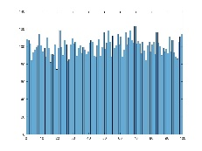 | 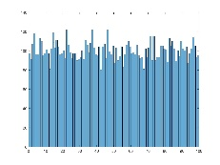 | 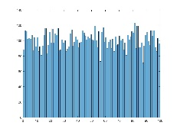 | 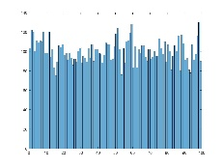 | 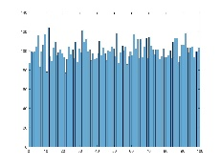 | 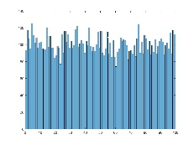 | 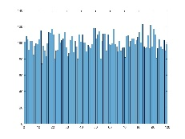
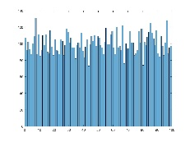 | 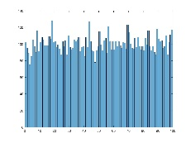 | 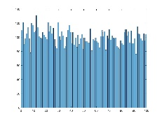 | 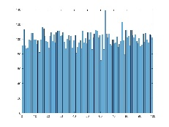 | 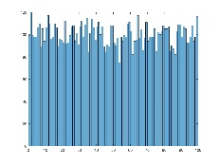 | 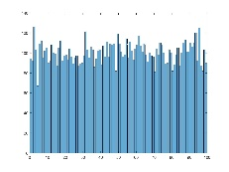 | 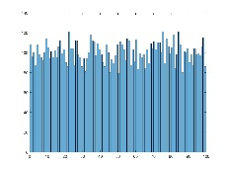
 |  |  |  | 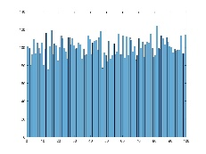 | 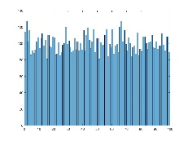 | 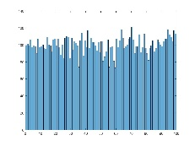
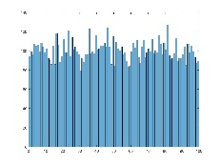 | 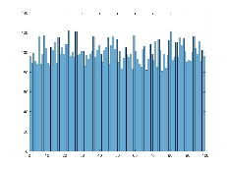 | 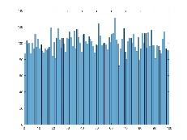 | 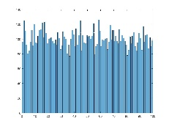 | 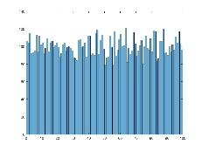 | 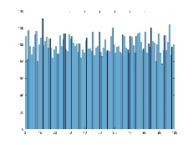 | 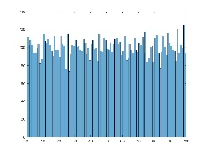
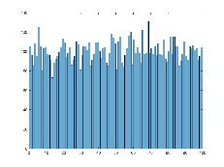 | 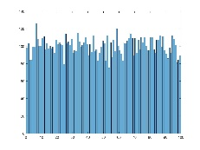 | 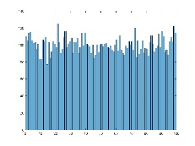 | 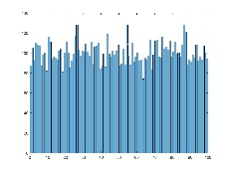 | 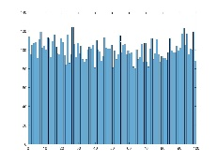 | 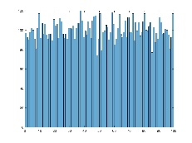 | 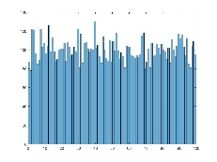
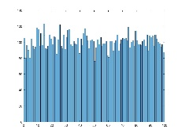 | 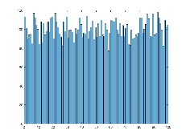 | 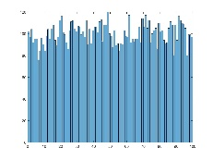 | 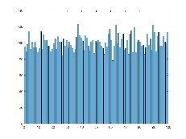 | 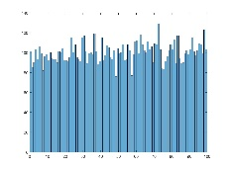 | 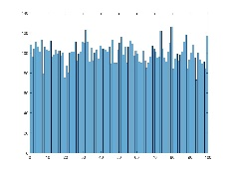 | 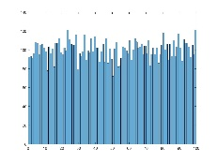
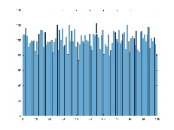 | 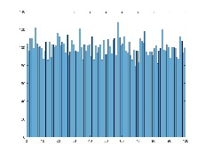 | 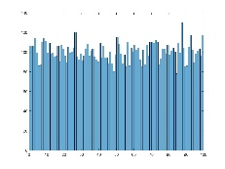 | 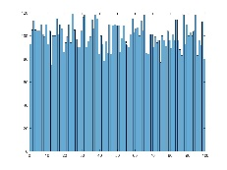 | 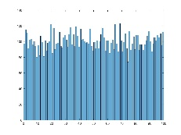 | 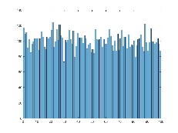 | 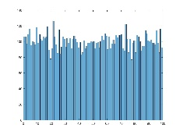

Figure 2: Ambiguous Distributions

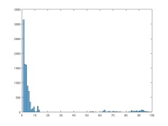 | 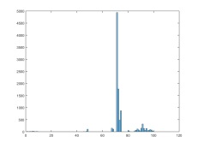 | 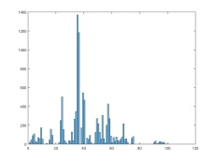 | 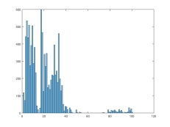 | 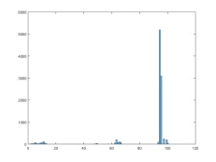 | 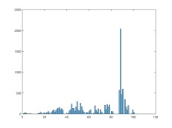 | 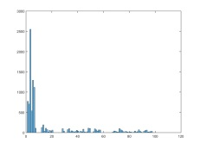
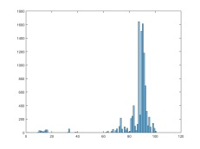 | 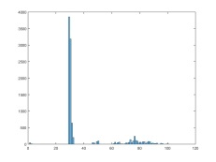 | 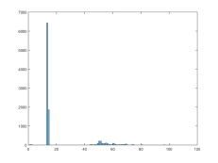 | 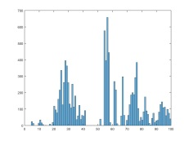 | 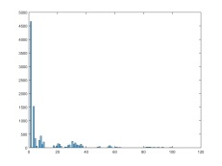 | 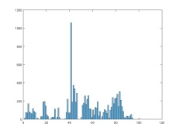 | 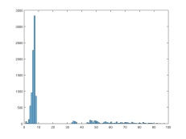
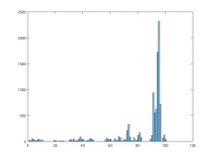 | 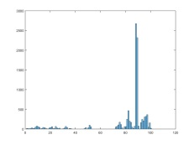 | 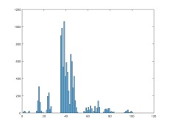 | 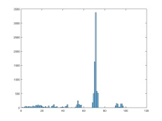 | 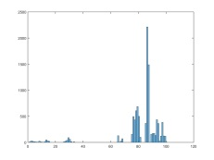 | 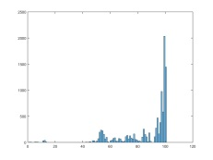 | 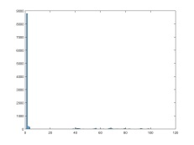
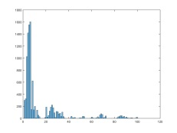 | 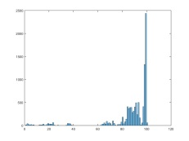 | 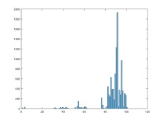 | 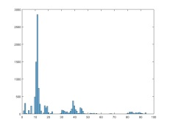 | 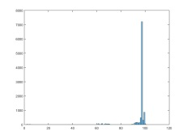 | 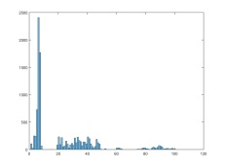 | 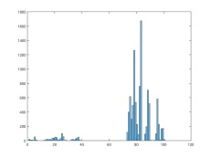
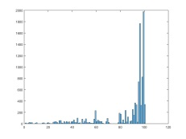 | 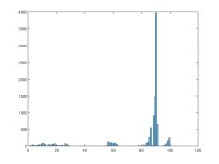 | 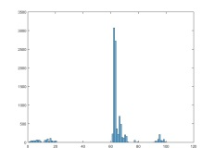 | 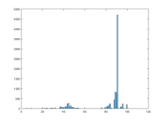 | 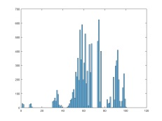 | 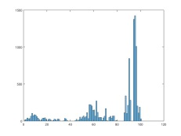 | 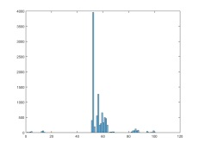
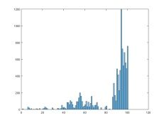 | 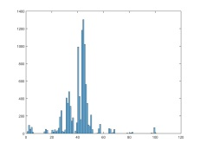 | 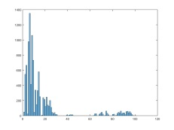 | 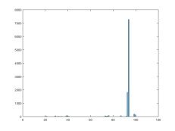 | 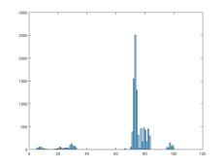 | 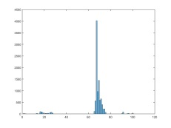 | 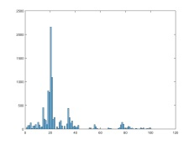
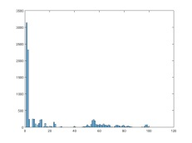 | 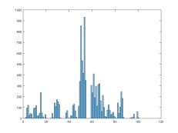 | 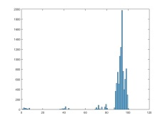 | 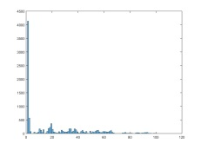 | 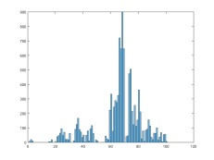 | 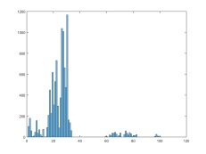 | 